Futures
David Leitch
2024-02-13

Chart of the day - Flat load futures are falling
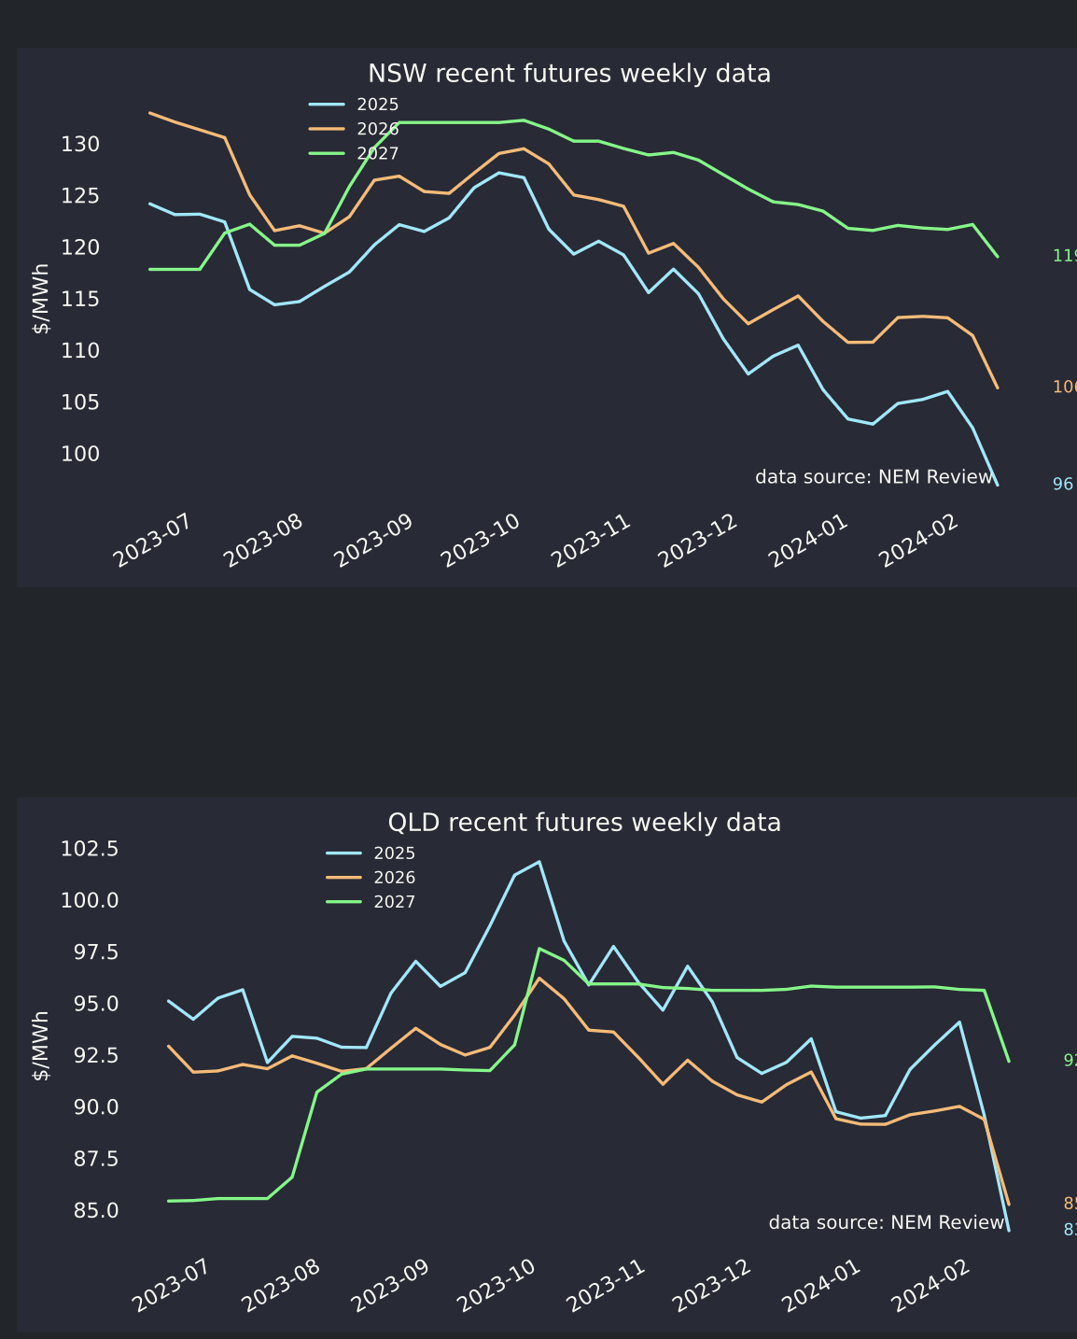
“NSW annd QLD”
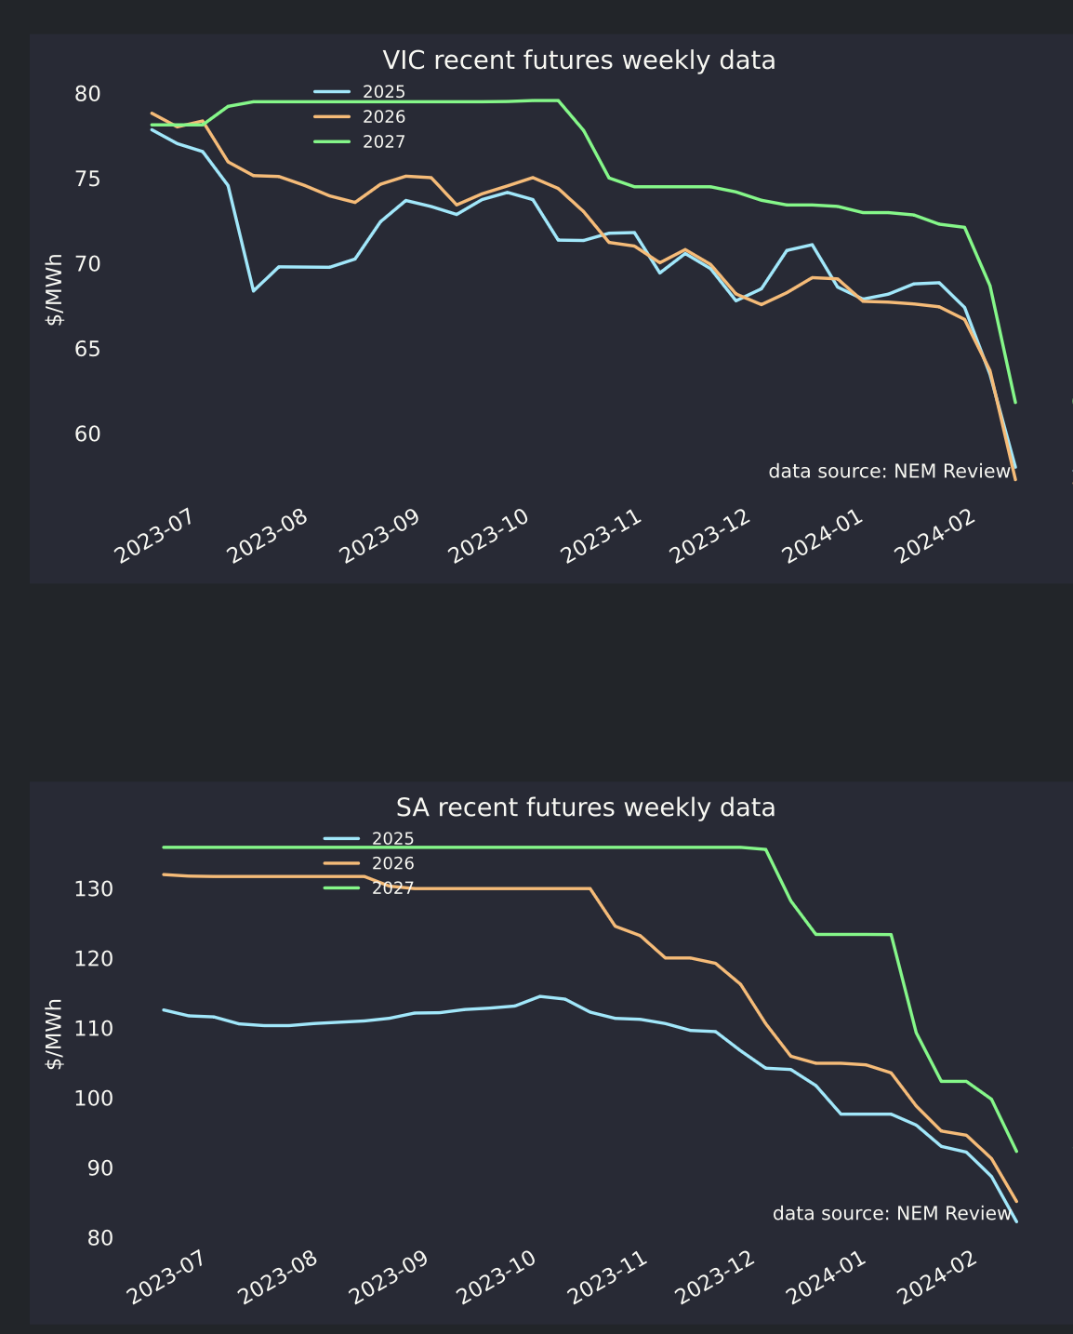
“Vic and SA”

